The Case of
The Murphy Family

using measuring to solve a crime

Alison Graham
Teachers notes
The case of The Murphy Family
____________________________
Syllabus links:
Junior Certificate Science: 3A1 Measurement in science: measuring and recording length
Aims an Objectives, Skills: -observation, measurement, accurate recording of data
- logical thinking, formation of opinions and judgements based on evidence
Equipment required:
Rulers

What you need to do in advance:
Photocopy sheets

Expected results:
Suggested answers to questions:

- How many vehicles have left their tracks at the house? 3 different vehicle
What is the evidence for your answer?
Evidence: vehicle 1 tyre width: 0.2 cm, total width of track: 2.1 cm
vehicle 2 tyre width: 0.3 cm, total width of track: 2.3 cm
vehicle 3 tyre width: 0.4 cm, total width of track: 2.4 cm

- Which tracks are left by the Murphy family car? The narrow tyre width track
What is the evidence for your answer?
The narrow tyre width track matches the measurements made of the Murphy family car

- Is there evidence that Tom Kearney’s vehicle visited the house? ……No……
What is the evidence for your answer?
Tom Kearney’s jeep - tyre width: 0.4 cm, total width of track: 2.1 cm
Jeep tracks at the house - tyre width: 0.4 cm, total width of track: 2.4 cm

Student worksheet
The Case of The Murphy Family
The crime
On 28th August 2009 the Murphy family came back from holiday to find that their house had been broken into and some large bits of furniture and their enormous TV were missing.
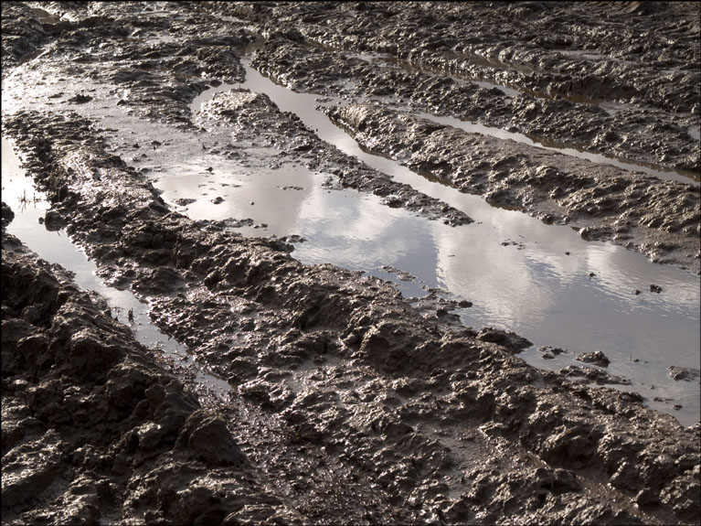
The weather had been bad in their absence and there was a muddy puddle at the entrance to their driveway. Cars driving through it had left muddy tracks on the driveway. The Forensic team think that these may give useful clues and have made images of them which are shown on the map.

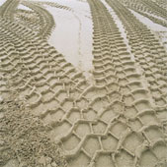
The police have arrested a known burglar, Tom Kearney, and the Forensic team have made images to the same scale of the tracks of his jeep. They have also made images of the Murphy family car so that these tracks can be excluded.

You are part of the Forensic team and you are to be called on in court to answer the questions below.
(Hint: Remember the defence lawyer can make mincemeat of you if you rely on your opinion! Measurements are much more impressive to the judge or jury.)

Tom Kearney’s jeep
Murphy’s car

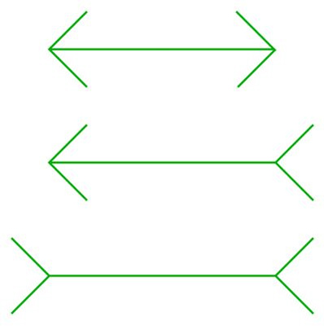
What you need to know!
1
Our eyes can often deceive us!
To accurately measure the lengths of a line you need to
- check the divisions on the ruler- are the marks every 0.1 cm or every 0.2 cm?
2
- have your eyes directly over the ruler when determining length
Measure the lengths of these lines. What do you find?
1 = 2 = 3 =
3

Measure the lengths of these men- what do you find?

1 =

2 =
1
3 =
What you need to do
to solve the crime!
Now use your measuring skills to gain
information about this crime!

You need to use all your powers of observation!
2
- Remember that tyres can differ in width and
pattern and how far apart they are!
3

- Your answer can be interpreted in different ways if it
has no units!
What have you found out?
- How many vehicles have left their tracks at the house? ………………
What is the evidence for your answer? ………………………………………
………………………………………………………………………………………
………………………………………………………………………………………
- Which tracks are left by the Murphy family car? …………………….
What is the evidence for your answer? ………………………………………
………………………………………………………………………………………
………………………………………………………………………………………
- Is there evidence that Tom Kearney’s vehicle visited the house? ………………
What is the evidence for your answer? ………………………………………
………………………………………………………………………………………
…………………………………………………………………………………………..
…………………………………………………………………………………………..

